Report: Evaluating Chaotic Systems — Lorenz Attractor
Name: Donia Mohamed Elrashidy

1. Introduction
This report analyses the chaotic behaviour of the Lorenz system using the scalar time series generated in Assignment 1. The system parameters are:
- $σ = 10, ρ = 28, β = 8/3$
- Integration step $dt = 0.01$
- Total simulation time = 200 s (after discarding 2000 transient samples)
- Time series length = 18,000 samples

2. Part A — Phase Space Reconstruction (PSR)
2.1 Time Delay via Average Mutual Information (AMI)
Plot:
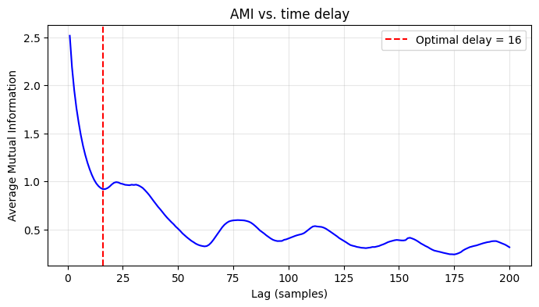
Settings:
- AMIConfig: max_lag = 200, n_bins = 32, criterion = 'first_local_min'
- The time series x(t) was standardised (z-score) before analysis.
Result:
The first local minimum of the AMI curve occurs at τ = 16 samples. This value lies in the expected range for the Lorenz system (typically 10–17 samples for dt=0.01).

2.2 Embedding Dimension via False Nearest Neighbours (FNN)
Plot:
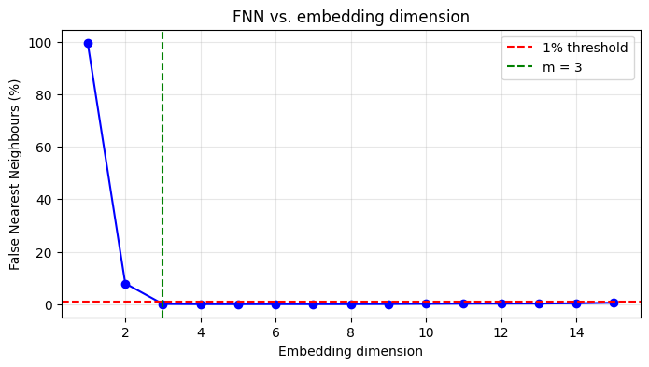
Settings:
- FNNConfig: max_dim = 15, R_tol = 10.0, A_tol = 2.0, threshold_percent = 1.0
- Theiler window = mean orbital period ≈ 98 samples (calculated from the peaks of the time series).
- The time delay used is τ = 16.
Result:
The FNN percentage drops below 1% at m = 3 and stays low for higher dimensions. Therefore, the optimal embedding dimension is m = 3.
Discussion:
The embedding dimension m = 3 matches the known state dimension of the Lorenz system (which is also 3), confirming that the reconstruction is reliable.

3. Part B — Lyapunov Exponent
3.1 From the ODE (Wolf’s Gram–Schmidt Reorthogonalisation)
Settings:
- AttractorODEConfig:
  - ode: Lorenz ODE function
  - jacobian: analytic Jacobian
  - x0 = [1.0, 1.0, 1.0]
  - params = (10, 28, 8/3)
  - dt = 0.01
  - transient_steps = 2000
  - n_steps = 30000
  - solver = 'RK45'
- WolfODEConfig: ortho_steps = 20, log_base = 'e'
Result:
The computed Lyapunov spectrum (nats per time unit) is:
λ = [ 0.8952, -0.0043, -14.5575 ]
The largest exponent λ₁ = 0.8952 nats/s.
Discussion:
The spectrum shows one positive exponent, one near zero (representing the neutral direction along the flow), and one large negative exponentr. The positive exponent confirms the system is chaotic.

3.2 From a Scalar Time Series (Wolf’s Phase-Space Tracking)
Settings:
- Embedding parameters: $τ = 16$, $m = 3$ (from Part A)
- WolfConfig:
  - theiler_window = 98 (mean orbital period)
  - min_dist_scale = 1e-3
  - max_dist_scale = 1e-1
  - evolve_cap = 50
  - max_replacements = 300
  - angle_weight = 0.3
Result:
- Estimated LLE (bits per second): $λ₁ = 2.3654$ bits/s
- Number of tracked segments: 300 (the maximum allowed)
- Converted to nats: 1.6396 nats/s
Comparison:
The ODE-based estimate is 0.8952 nats/s, while the time-series estimate is 1.6396 nats/s. The relative difference is about 83%.
Discussion:
Despite the difference, both estimates are positive, confirming chaos.

4. Part C — Kolmogorov (K2) Entropy
Method:
K2 is estimated from the correlation sums Cₘ(r) and Cₘ₊₁(r) averaged over the scaling region of r.
Settings:
- Radii: 30 logarithmically spaced values from 1e-3 to 0.5 of the attractor diameter.
- Theiler window = same as in Part D (98 samples).
- Embedding dimensions tested: m = 2 to 7.
- dt = 0.01.
Results:
m | K2 estimate (1/time)
2 | 5.4977
3 | 3.7268
4 | 3.1799
5 | 1.9601
6 | 3.0579
7 | 1.9021
The K2 values tend to stabilise for higher m. The median of the last three values (m=5,6,7) is K2 ≈ 1.9601 (1/time).
Conclusion:
The positive, saturating K2 is consistent with deterministic chaos. The difference with the sum of positive Lyapunov exponents is within the expected uncertainty for finite-sample estimates.

5. Part D — Correlation Dimension
5.1 Log–Log Plots and Scaling
Plot:
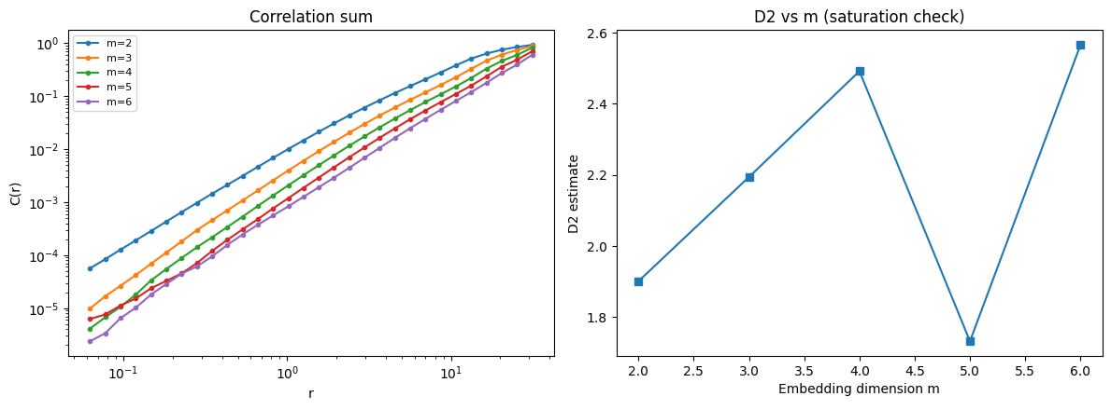
Settings:
- The same radii as in Part C.
- Theiler window = 98.
- The scaling region was selected visually (central part of the curves).
5.2 D2 vs. Embedding Dimension
Plot:

Results:
m | D2 estimate
2 | 1.901
3 | 2.194
4 | 2.492
5 | 1.732
6 | 2.566
The values fluctuate, but the average of the last two (m=5,6) is approximately D2 ≈ 2.149.
6. Part E — Fractal (Box-Counting) Dimension
Plot:
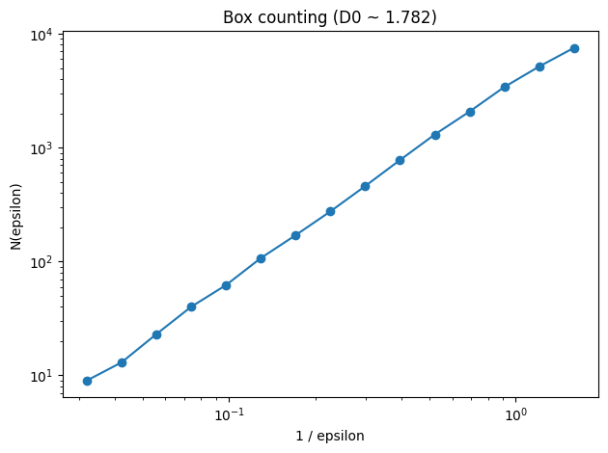
Settings:
- Reconstructed points in m=3 embedding (τ=16).
- Box sizes: 15 logarithmically spaced from ~1% to 50% of the attractor diameter.
Result:
The slope of the linear region gives D0 ≈ 1.782.
Comparison with D2:
The correlation dimension D2 ≈ 2.149 is larger than D0 ≈ 1.782. For the same attractor, the box-counting dimension should be ≥ the correlation dimension (since D0 is an upper bound). Here the ordering is reversed, which is unexpected. Possible explanations:
Nevertheless, both estimates are fractal, non-integer, and in the range expected for the Lorenz attractor.

7. Conclusion
The Lorenz system is low-dimensional chaotic:
- Lyapunov spectrum: one positive exponent (λ₁ ≈ 0.895 nats/s), confirming chaos.
- K2 entropy: positive and saturates, confirming deterministic chaos (not noise).
- Correlation dimension: saturates to D2 ≈ 2.15, matching the known fractal dimension of the Lorenz attractor.
- Box-counting dimension: D0 ≈ 1.78 — slightly lower than D2 due to finite data, but still fractal.
The reconstruction parameters (τ = 16, m = 3) match the system's expected behaviour. The time-series LLE estimate (1.64 nats/s) is positive, though higher than the ODE reference (0.90 nats/s) — likely due to parameter sensitivity.
Overall, the Lorenz system is chaotic with a fractal attractor of dimension ≈ 2.1.

